# Story 1. Login

As a registered user  
I want login with my userid and password  
so that I can use the website.

## Acceptance criteria:

* Homepage is shown when the userid and password are correct.
* Loginpage with errormessage is shown when the userid are password are wrong.

## Wireframes:

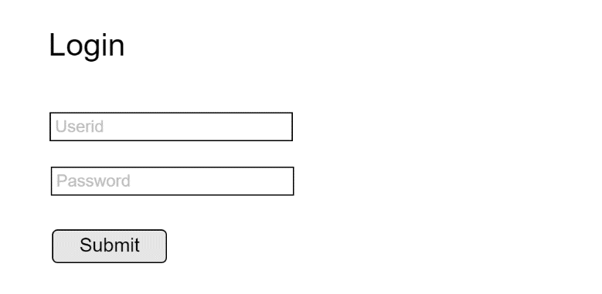

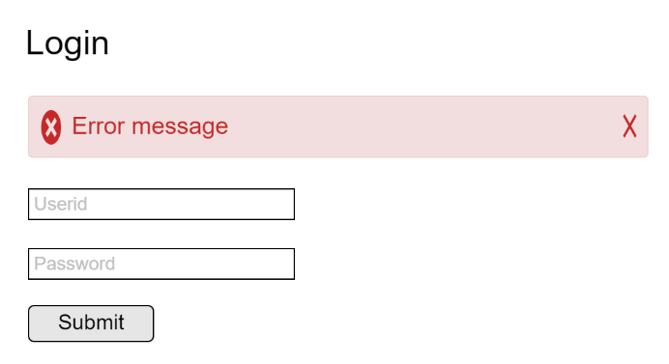

Wrong

Correct

